**Name -Parmeshwar\***

**Assignment ( GITHUB, JENKINS, Gradle, DOCKER & KUBERNETES)**

**Problem Statement: Automated Deployment of Web application**

**Q1) Design and develop tasks required to build CICD pipeline using ALL learned technologies to deploy WEB application on cloud platform as a set of microservices on containerized platform such as DOCKER. Deploy a web application on Docker container using GRADLE as build tool to install, test, package application. Push the code to Docker HUB and make it publicly available on internet. Pull this code from Docker Hub & Deploy it on KUBERNETES Cluster & create a pod with 3 Replicas. Access the Webpage from Kubernetes Worker Node using Node port service. Provision Infrastructure on AWS.**

**Step 1) created 3 instances**

**i) Kubernets master**

**i) Kubernets WorkNode**

**i) Jenkins master**

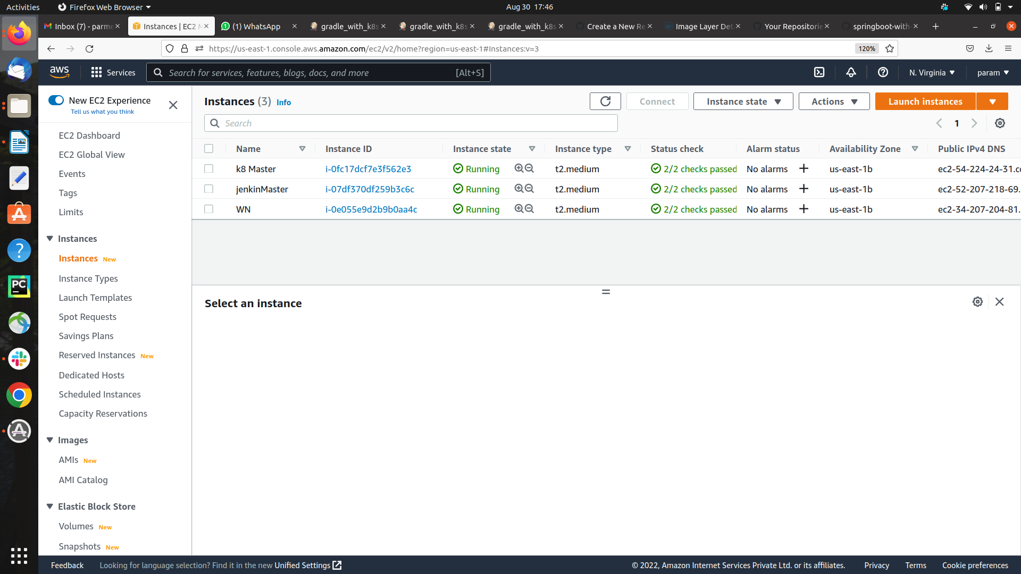

**step 2) created the job**

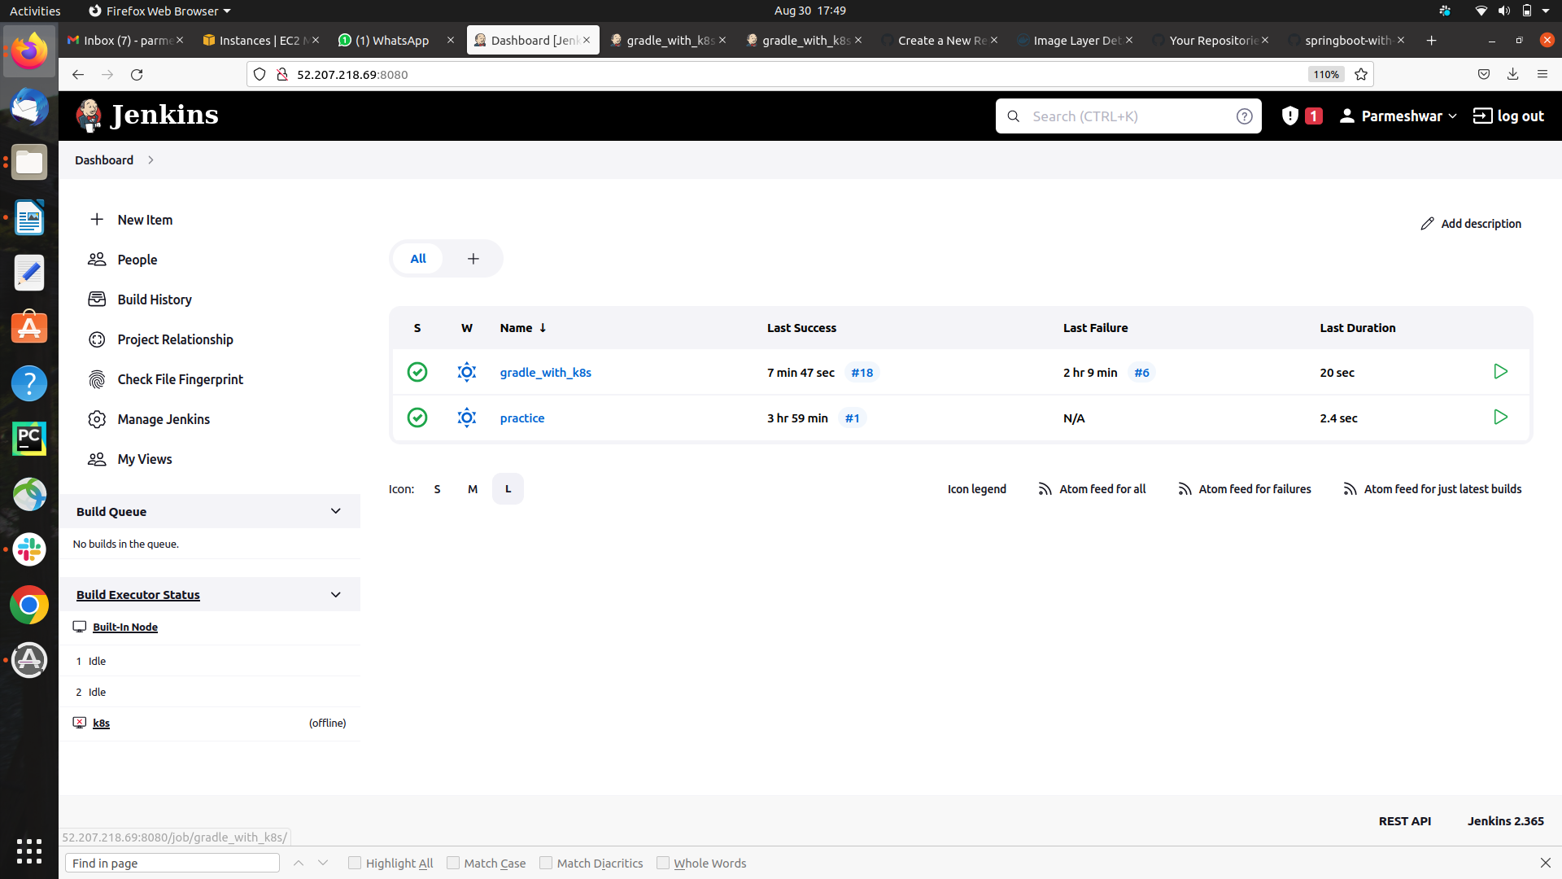

**step 3) pipeline script is written for execution**

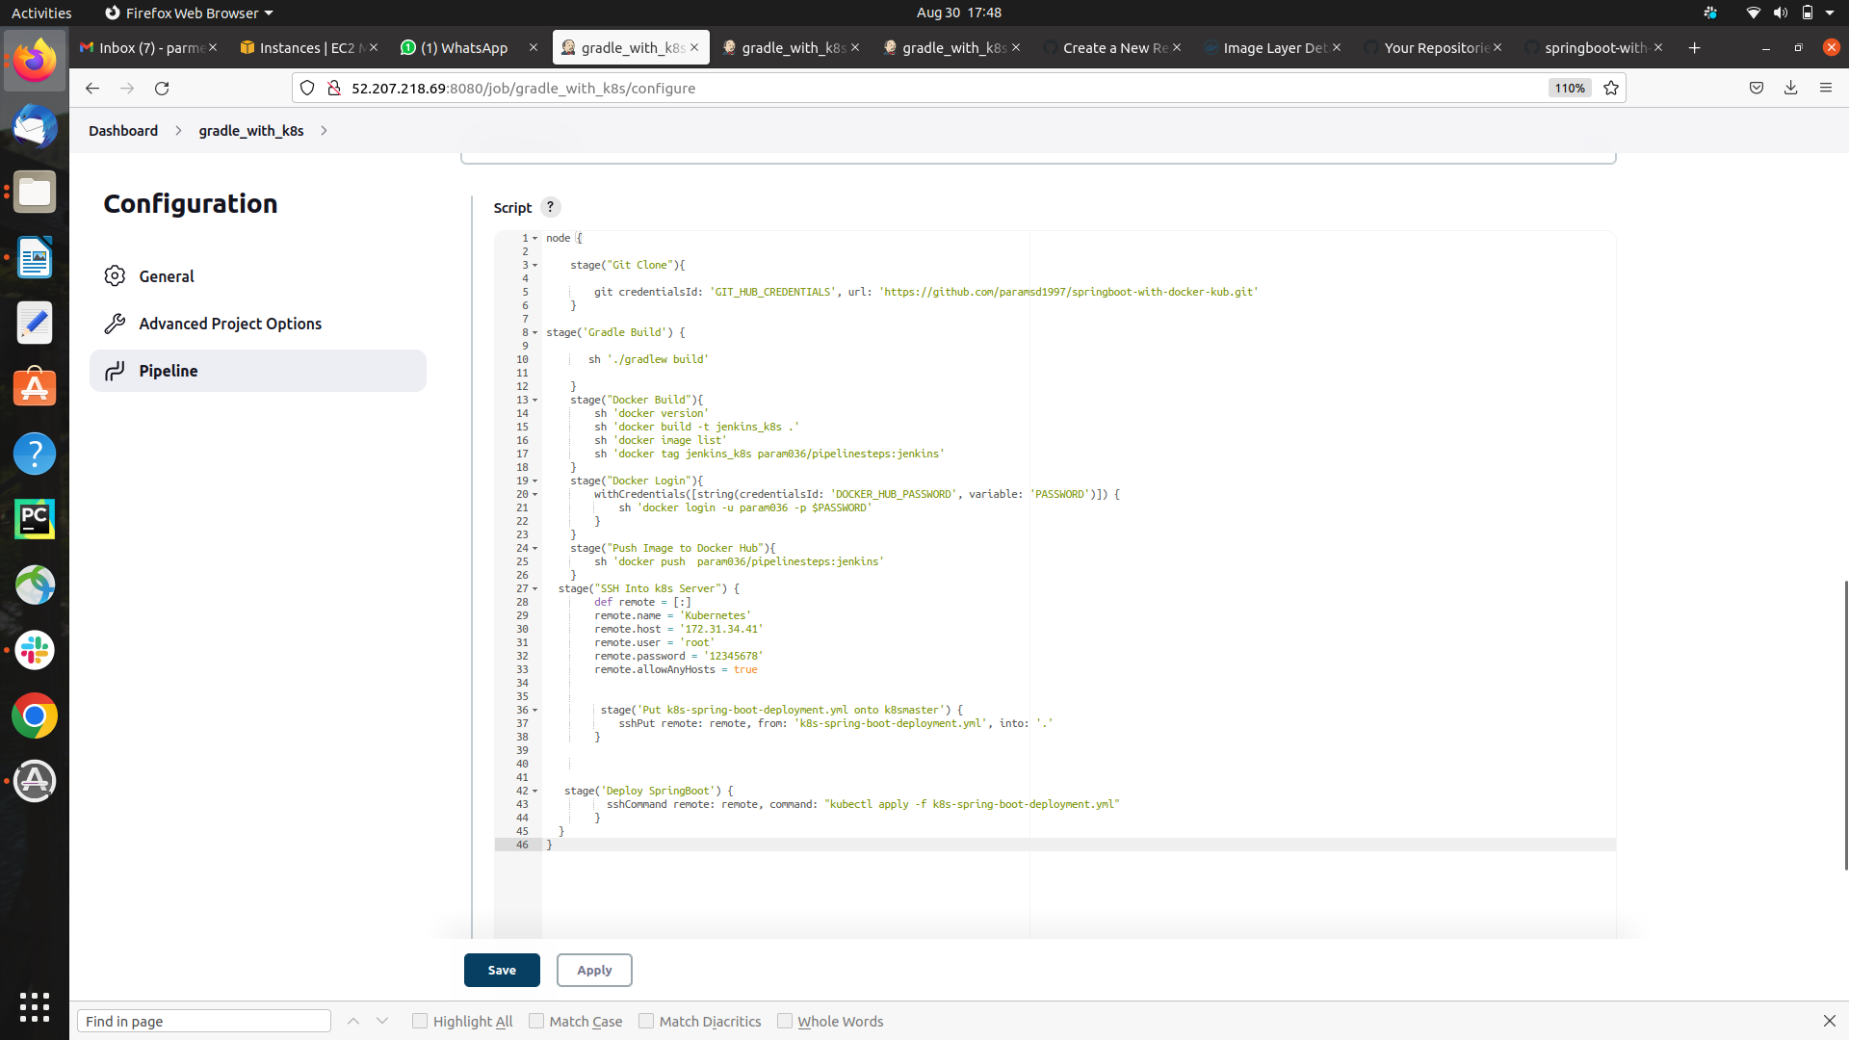

**step 4) Git repo Code**

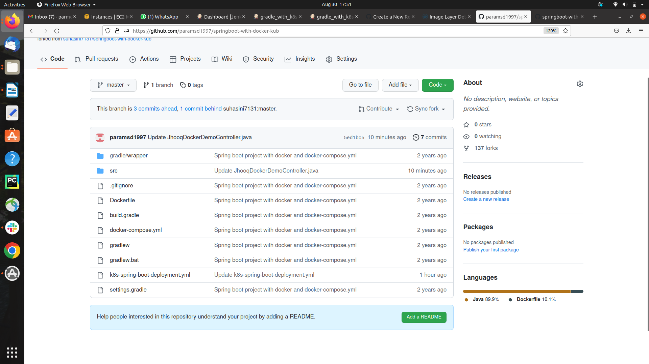

**step 5) git clone successfully**

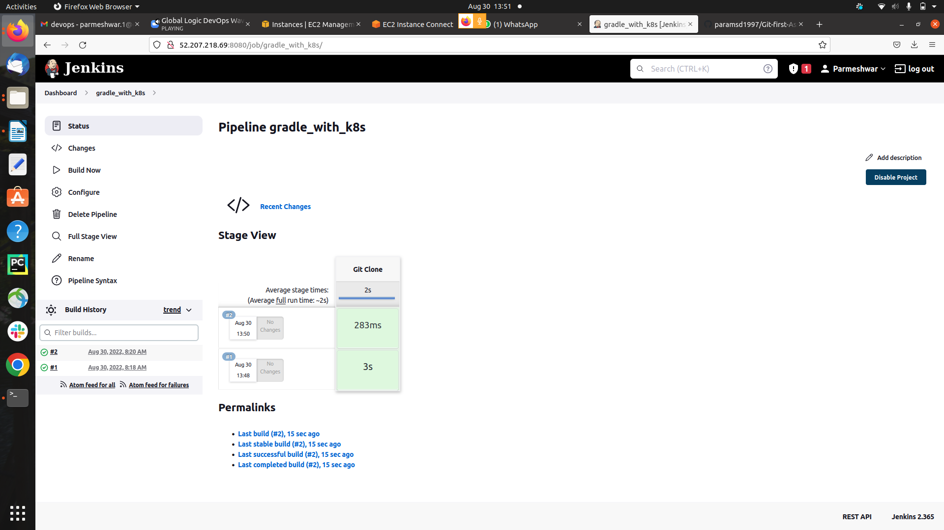

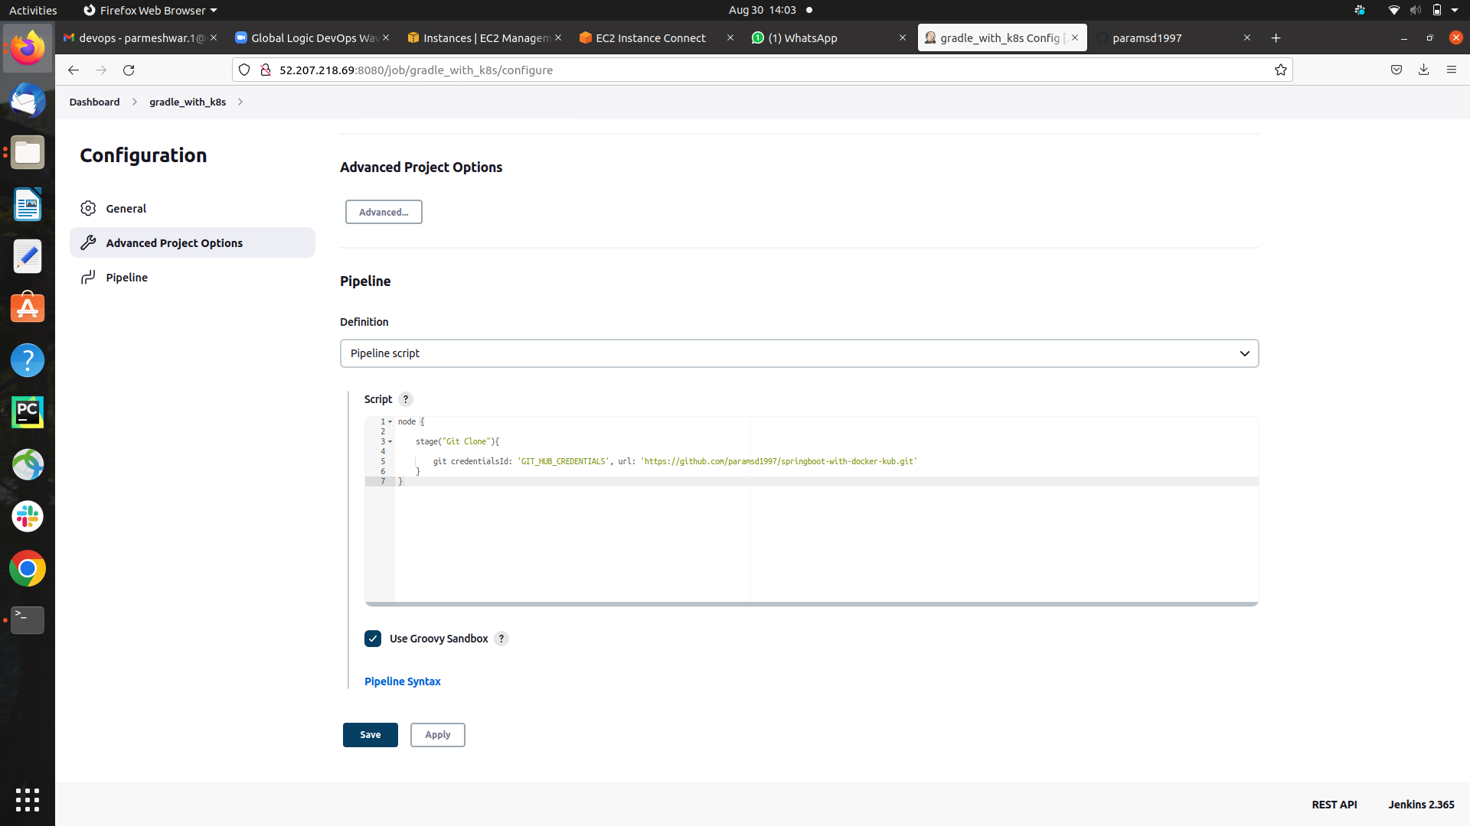

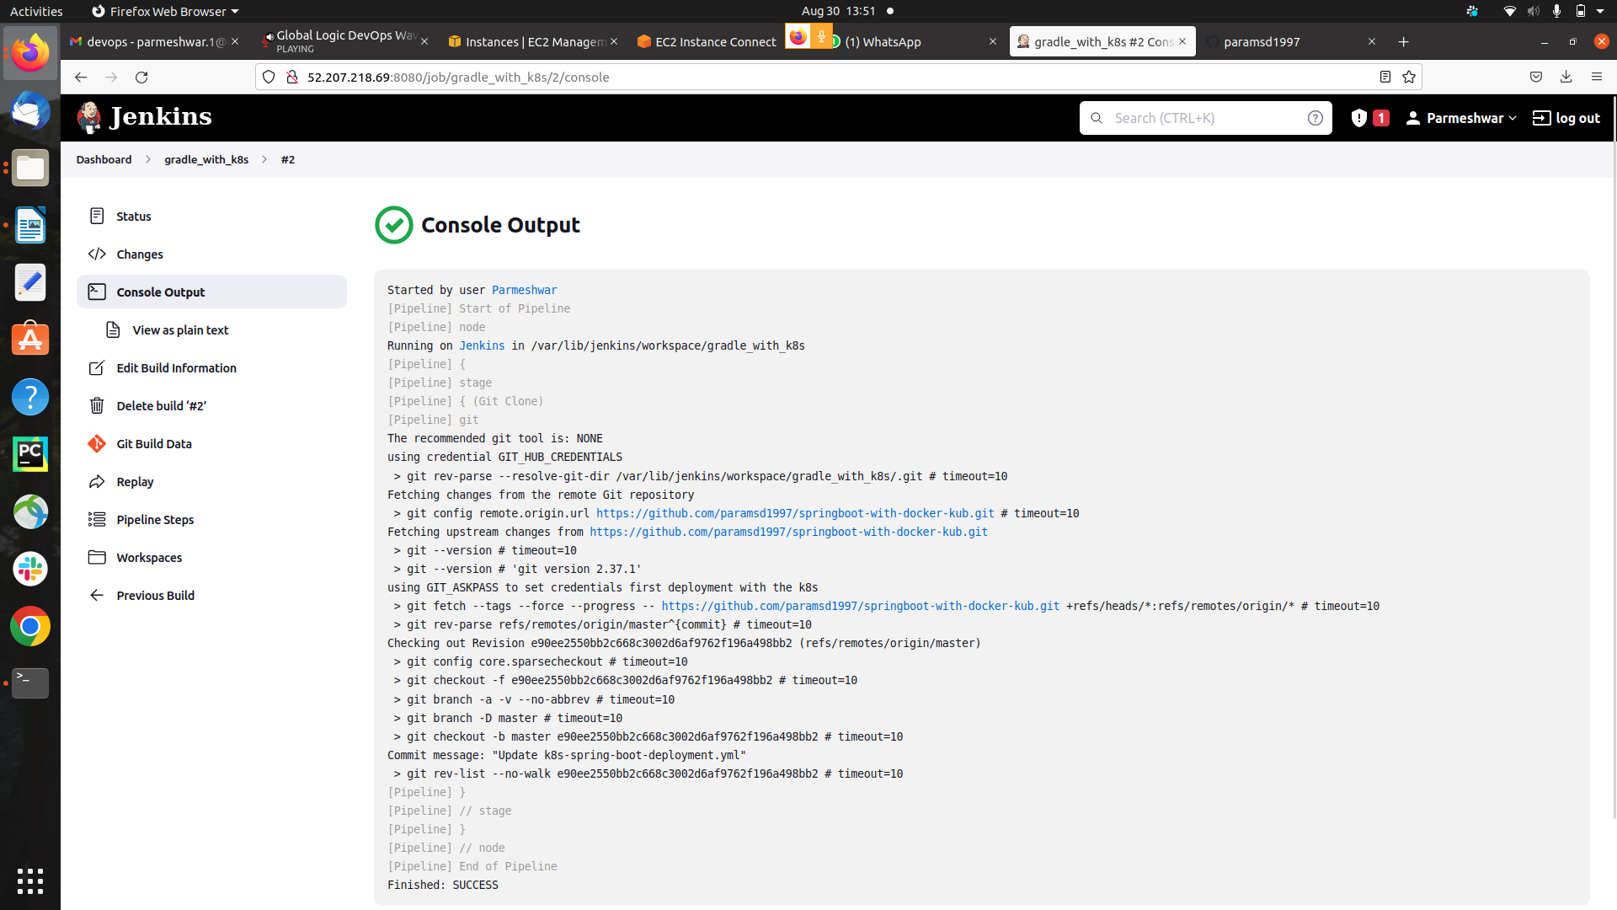

**step 5) Git Build Successfully**

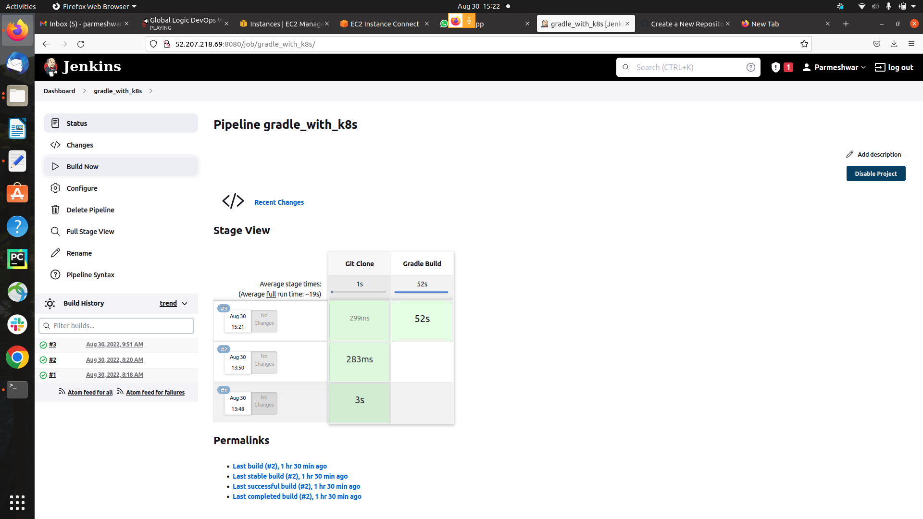

**Successfully builted**

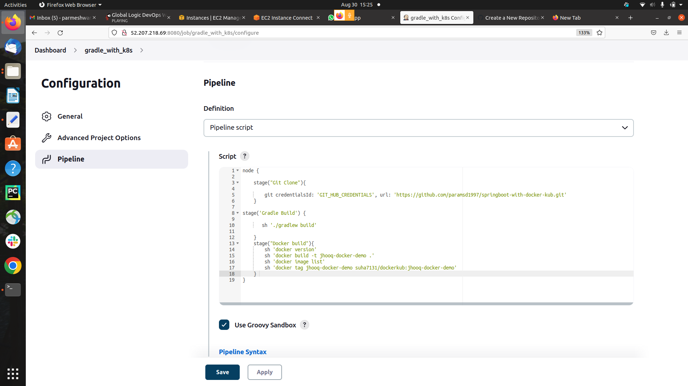

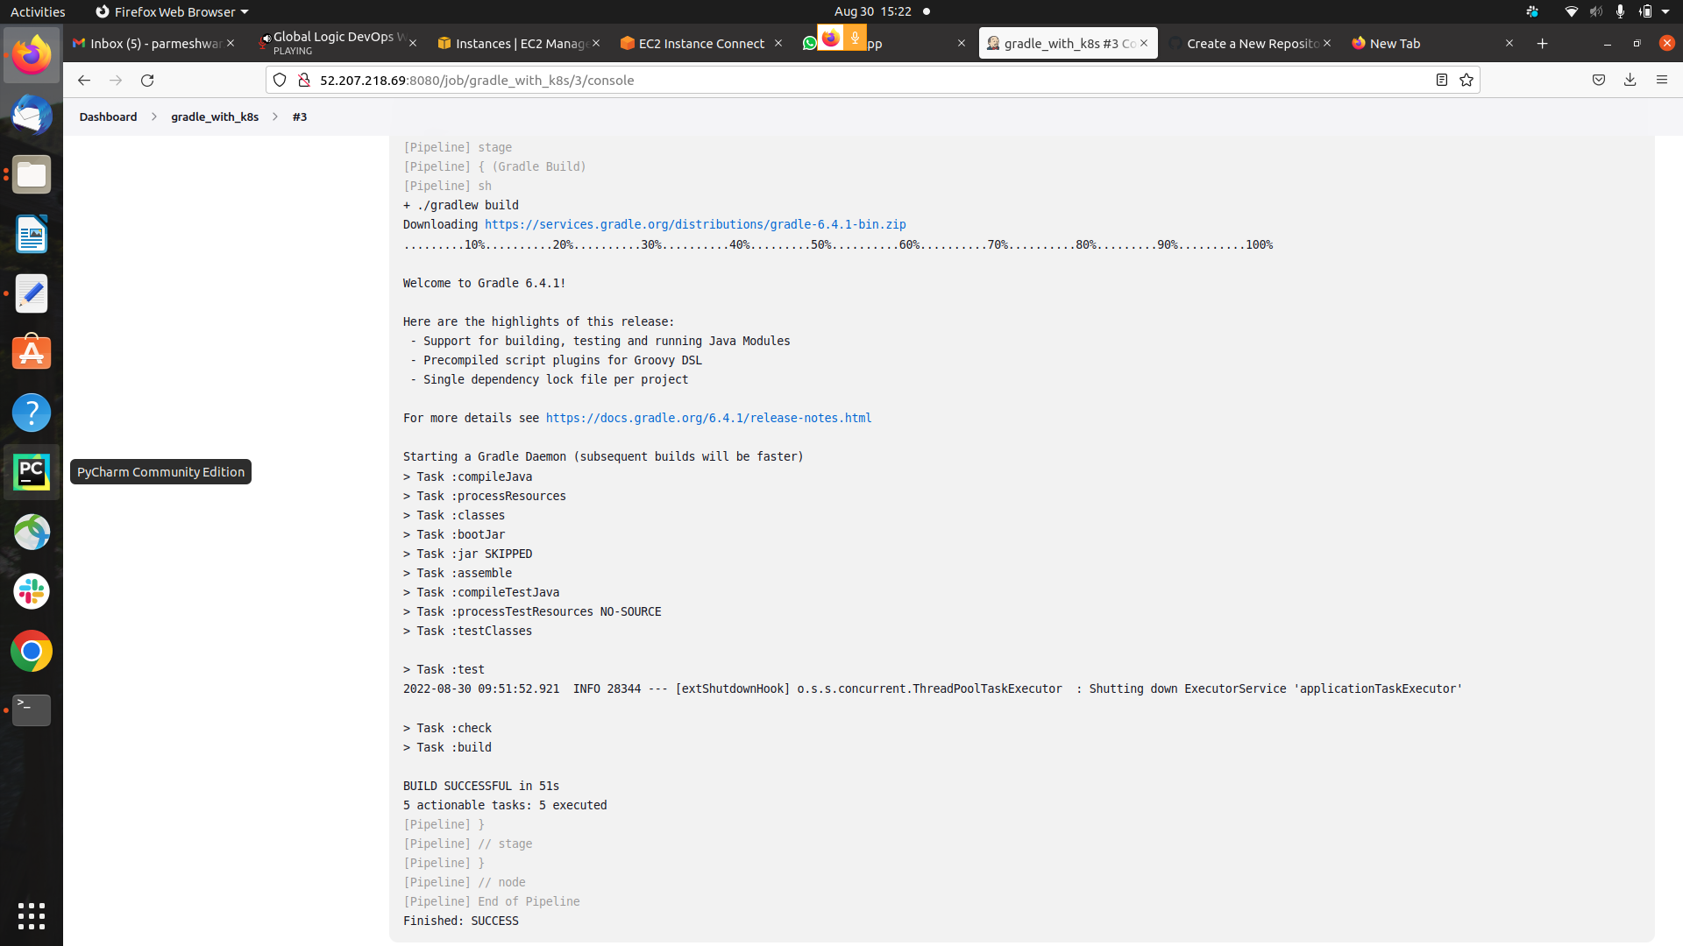

**step 6) Login to Docker hub and push to Docker hub**

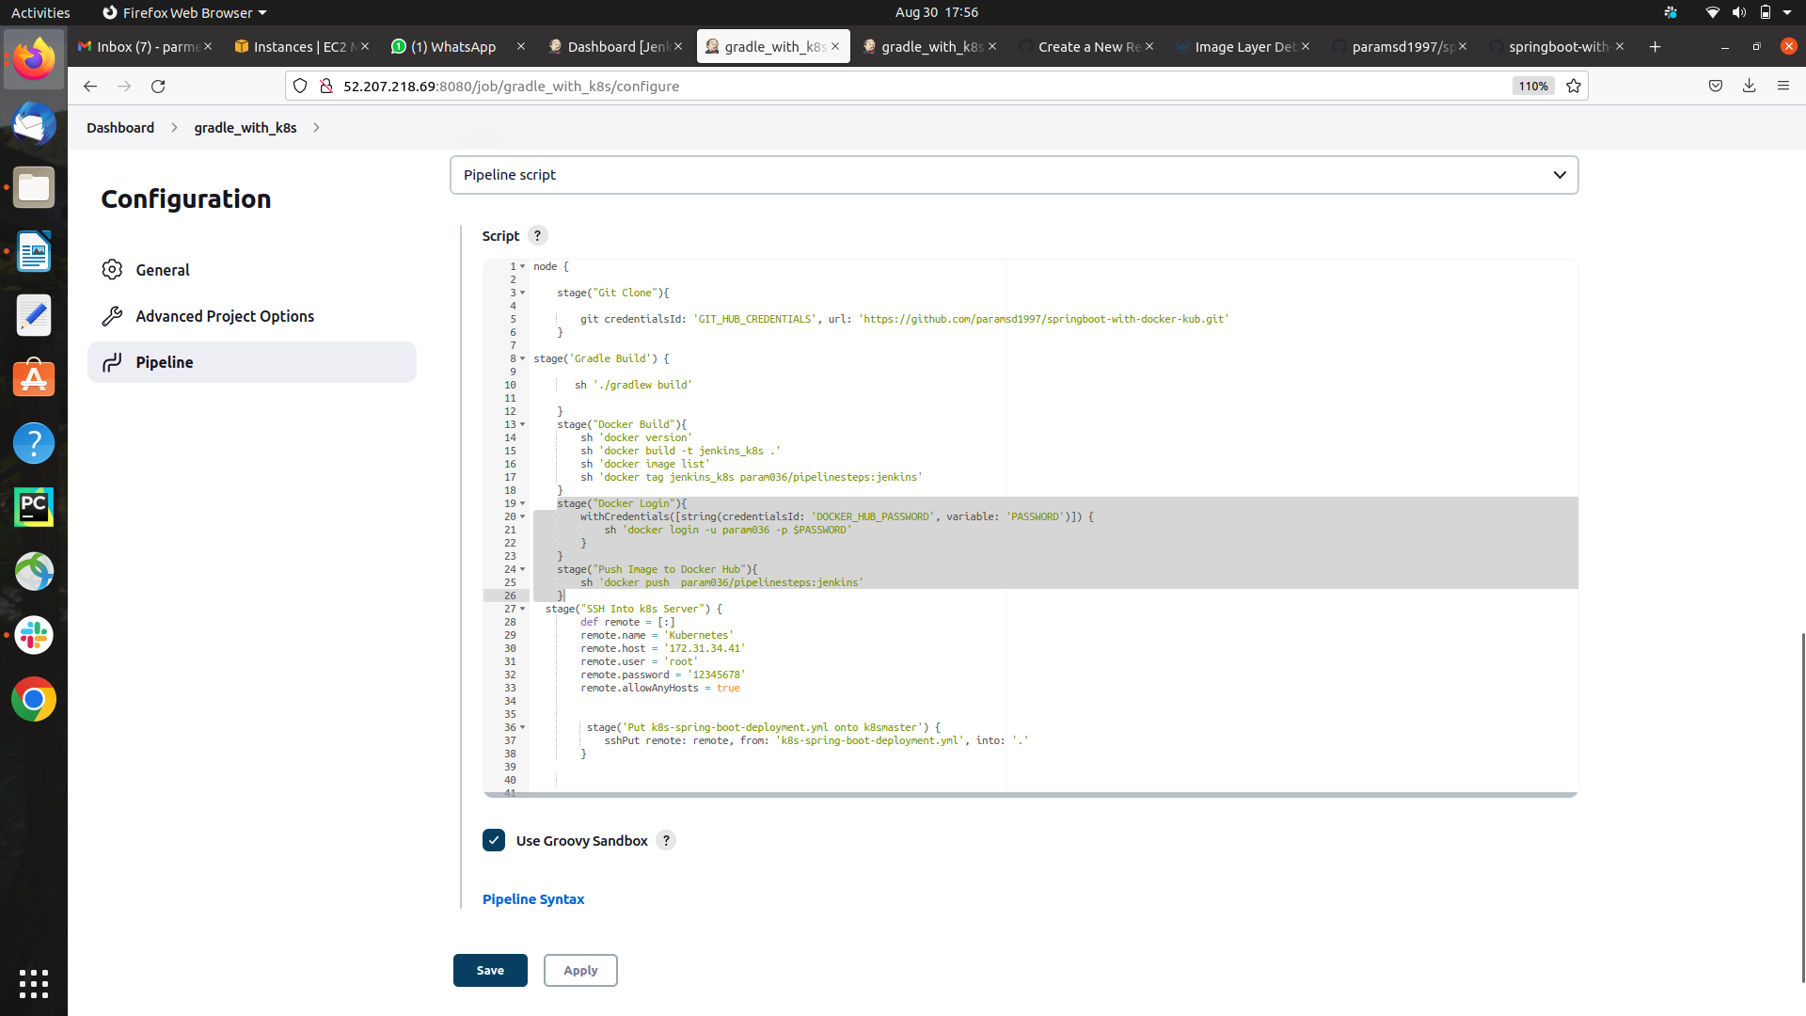

**login Succeed**

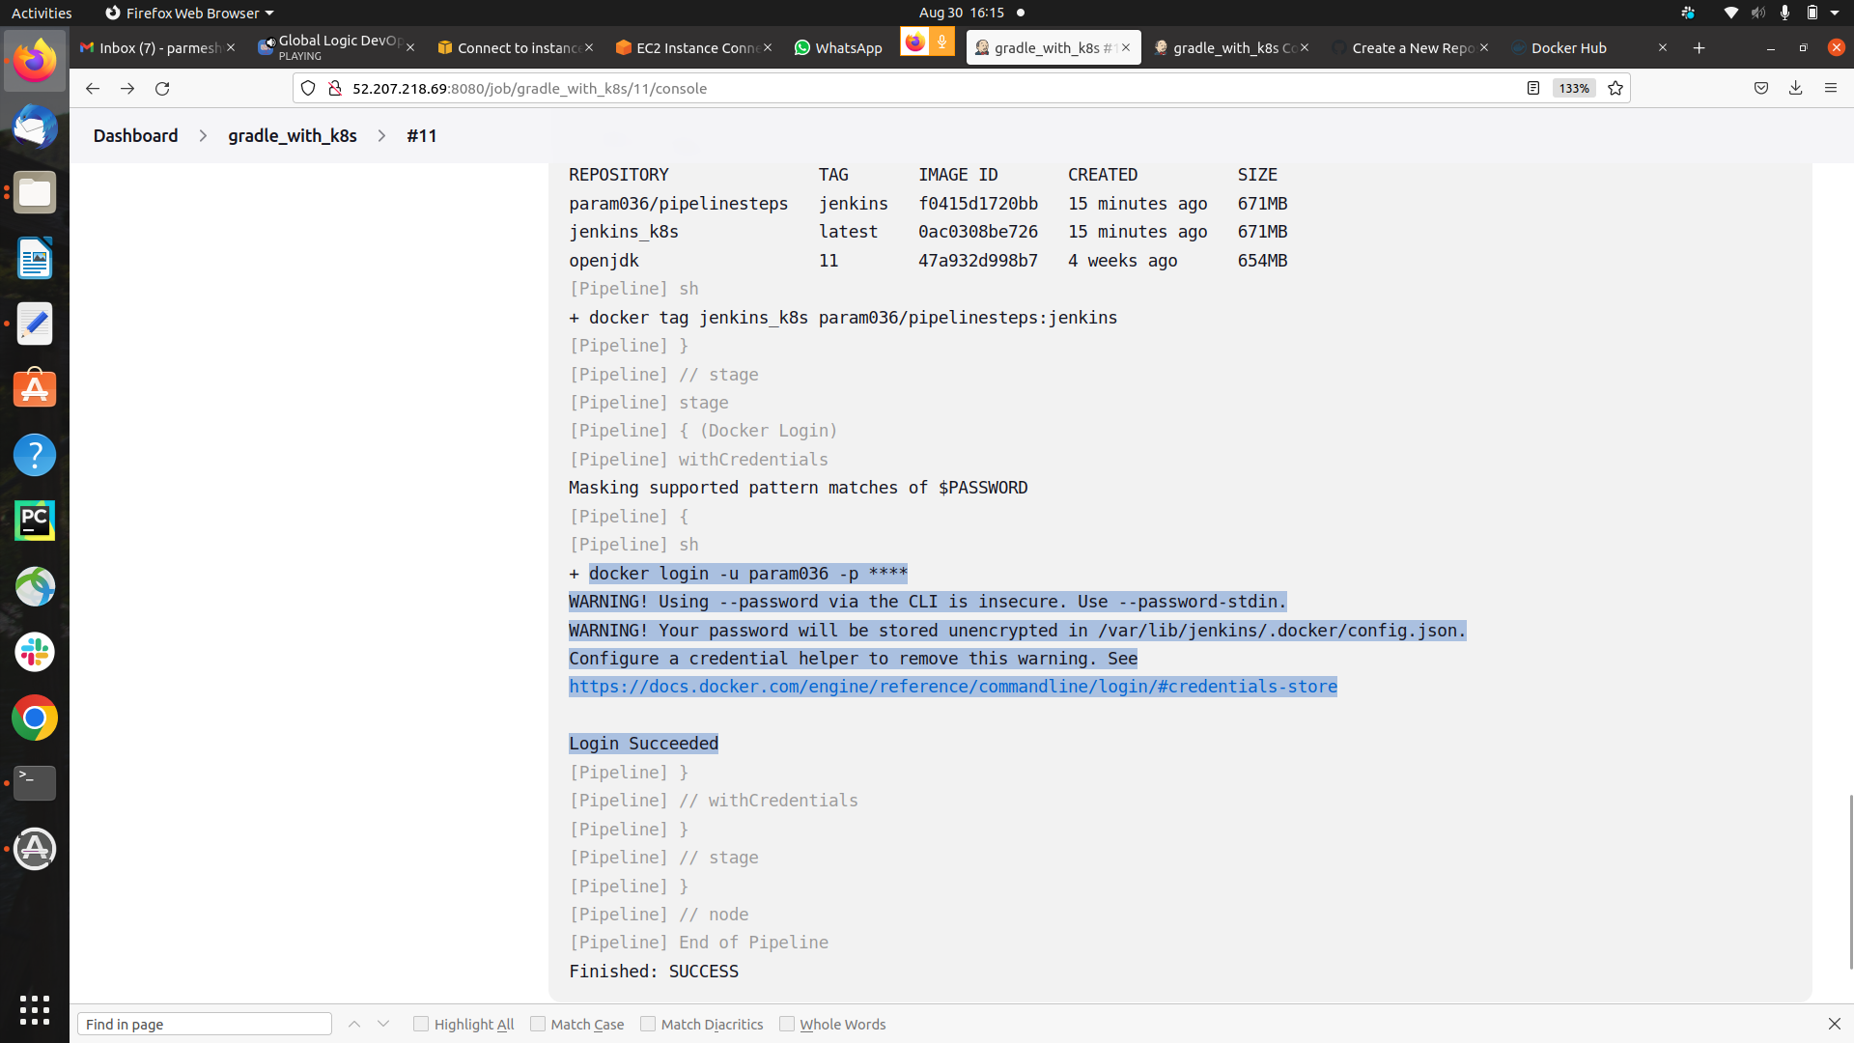

**Image Successfully Pushed to docker hub**

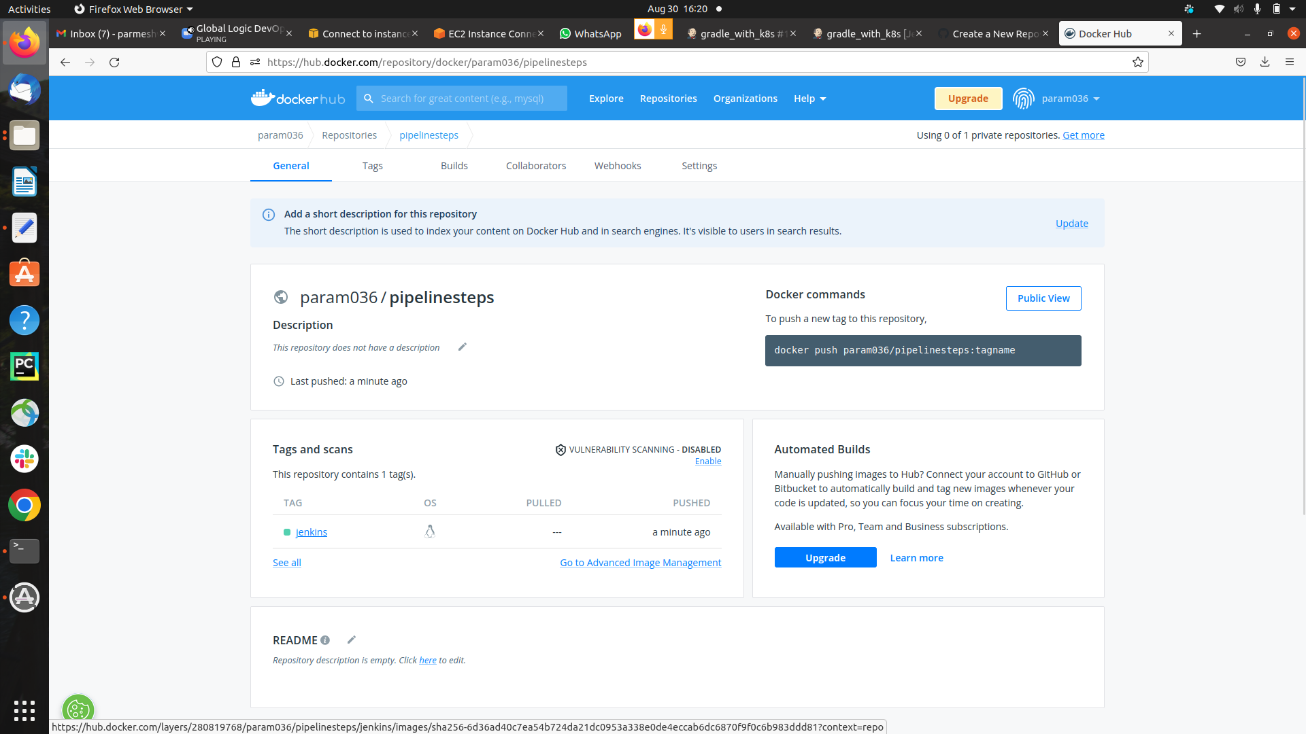

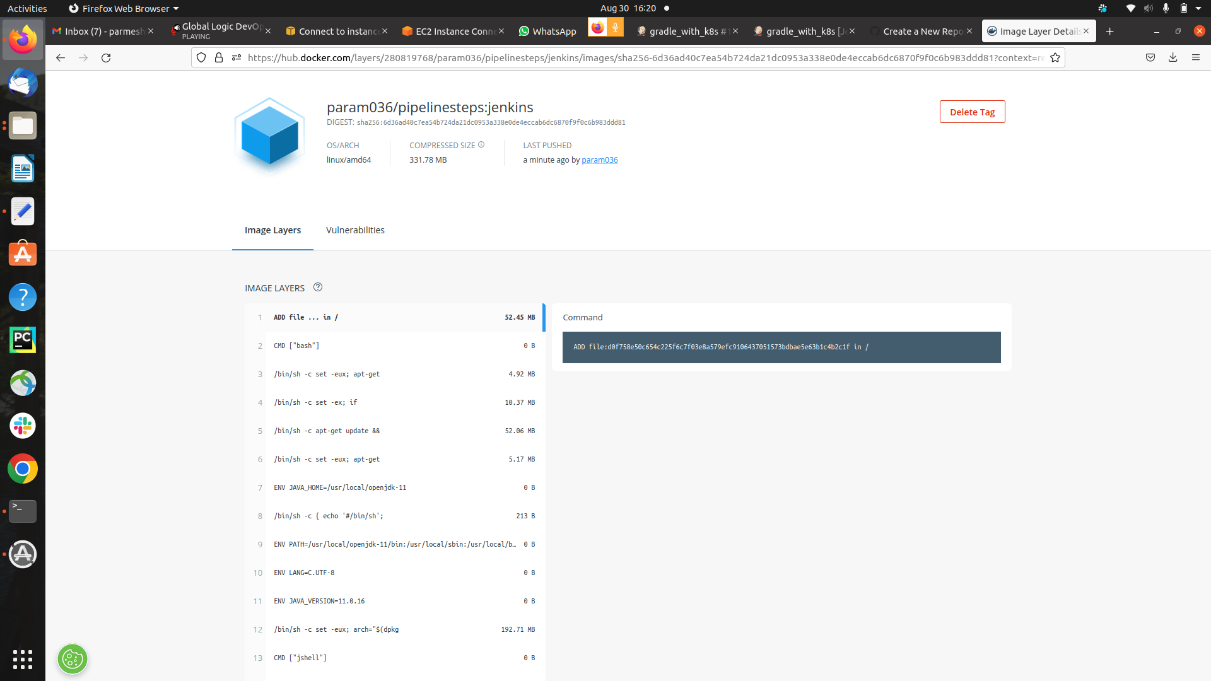

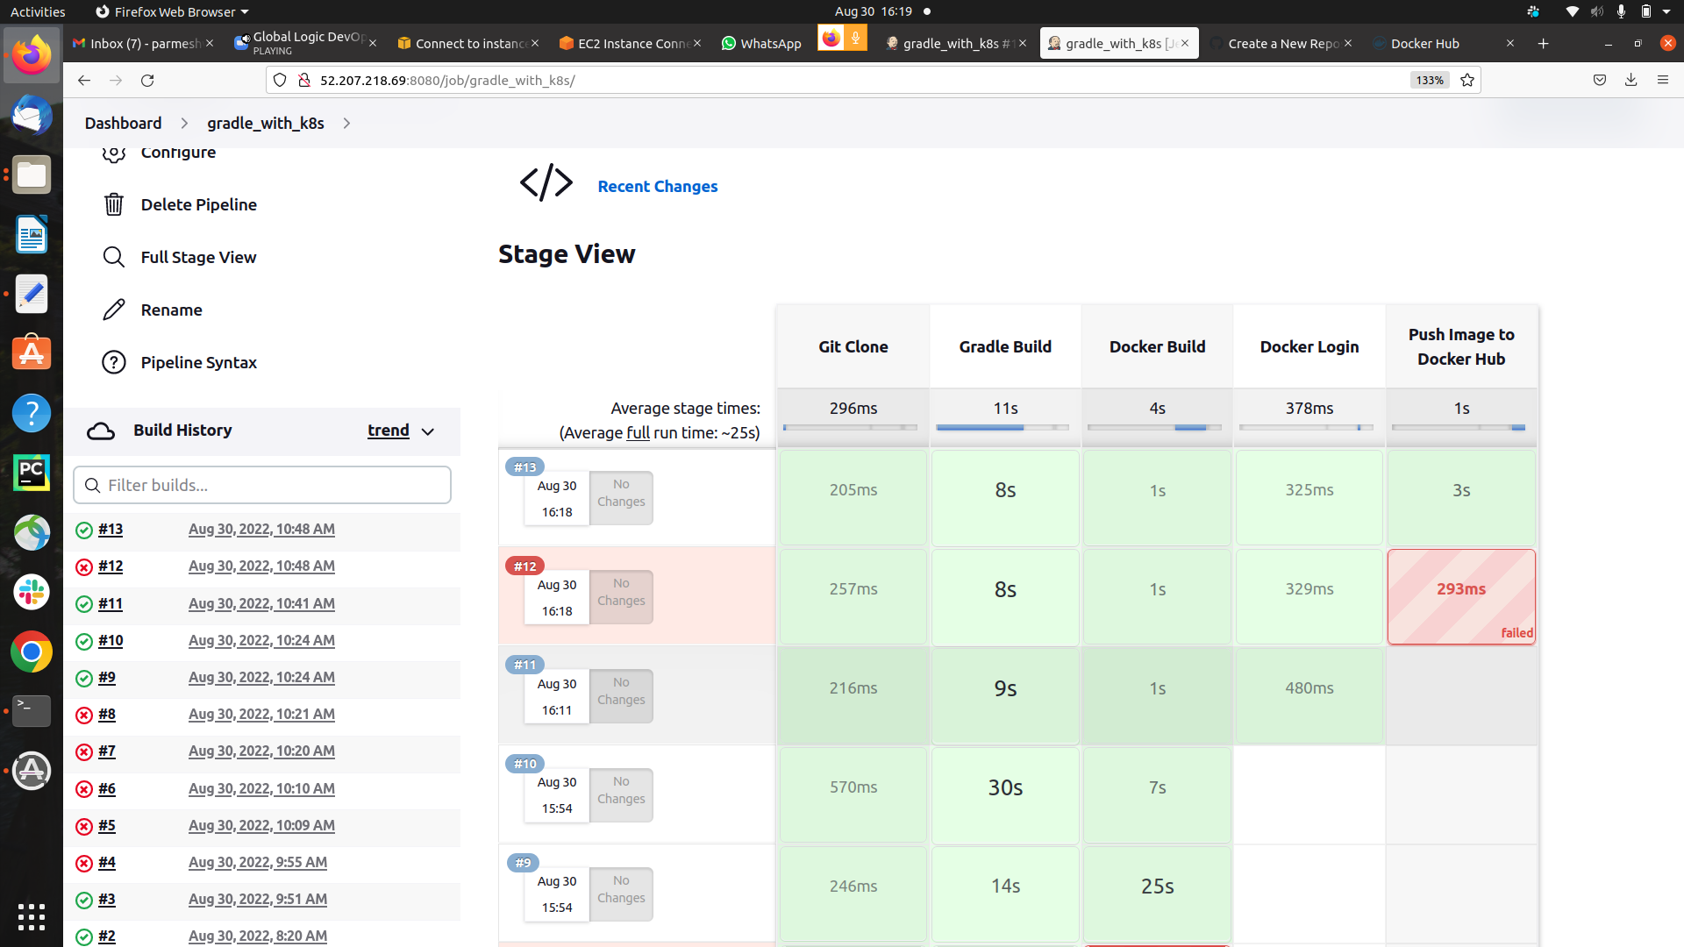

**step 8) Yml file for the creating the deployment with 3 replicas**

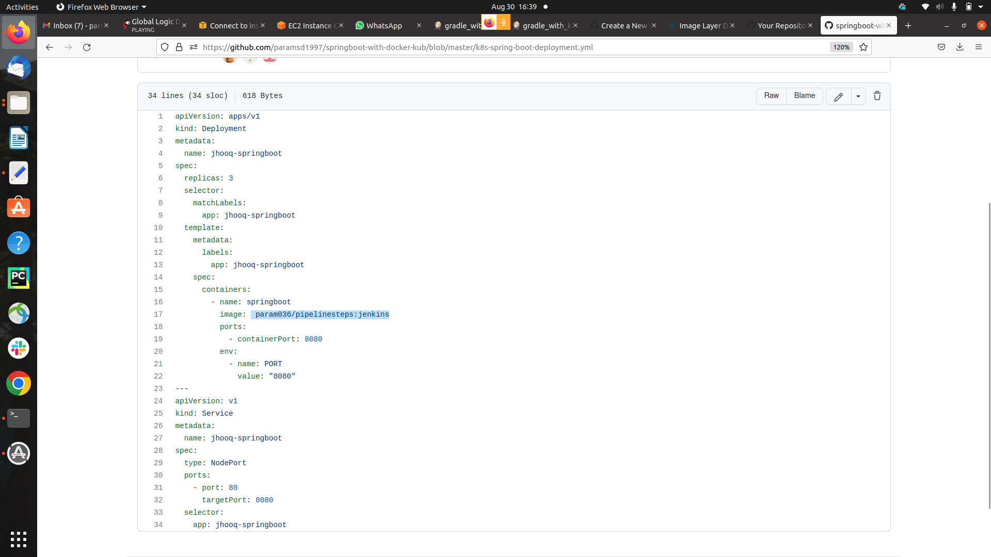

**step 8) Access the SSH of K8s MAster**

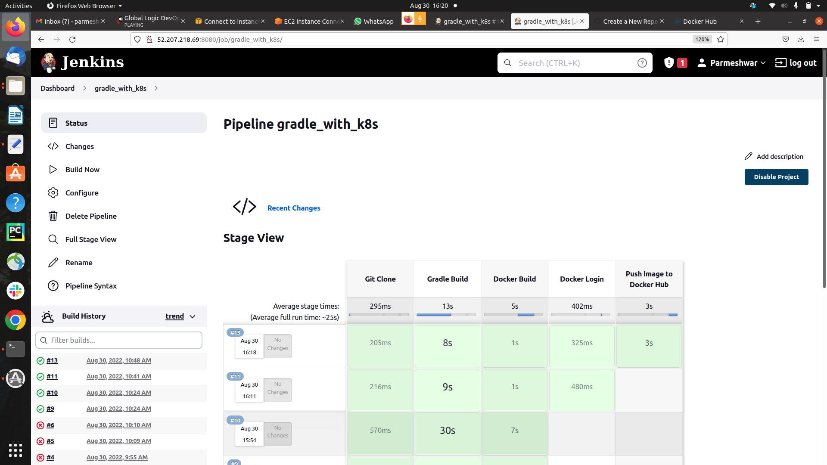

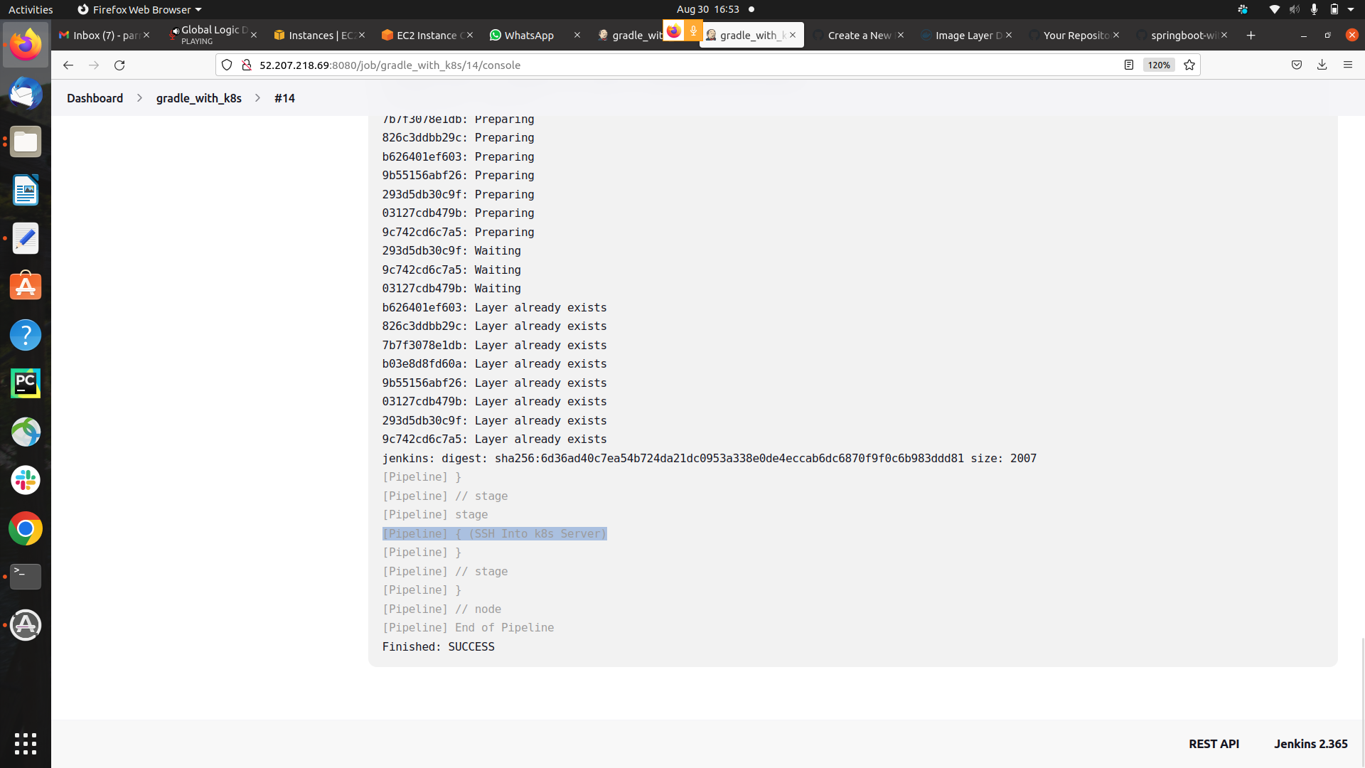

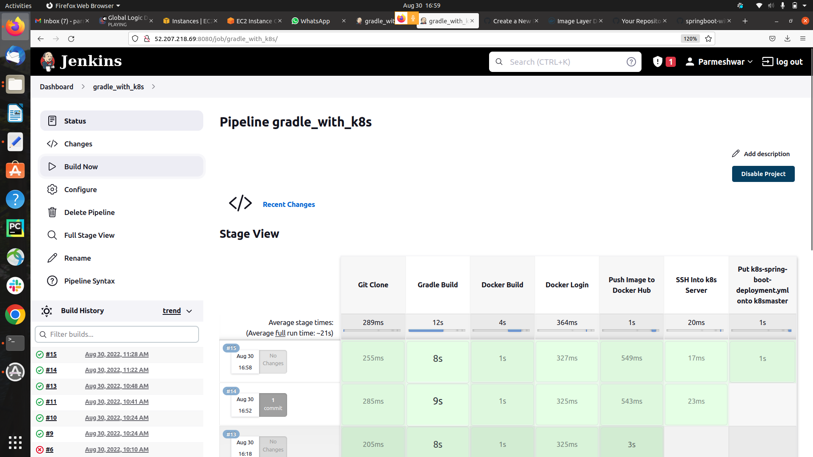

**Step 9) Now Moving the yml file to the k8s server using SSH**



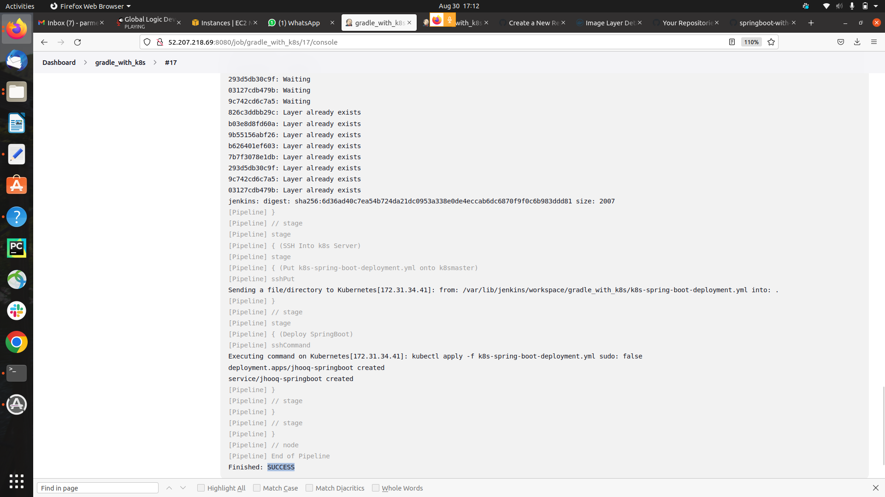

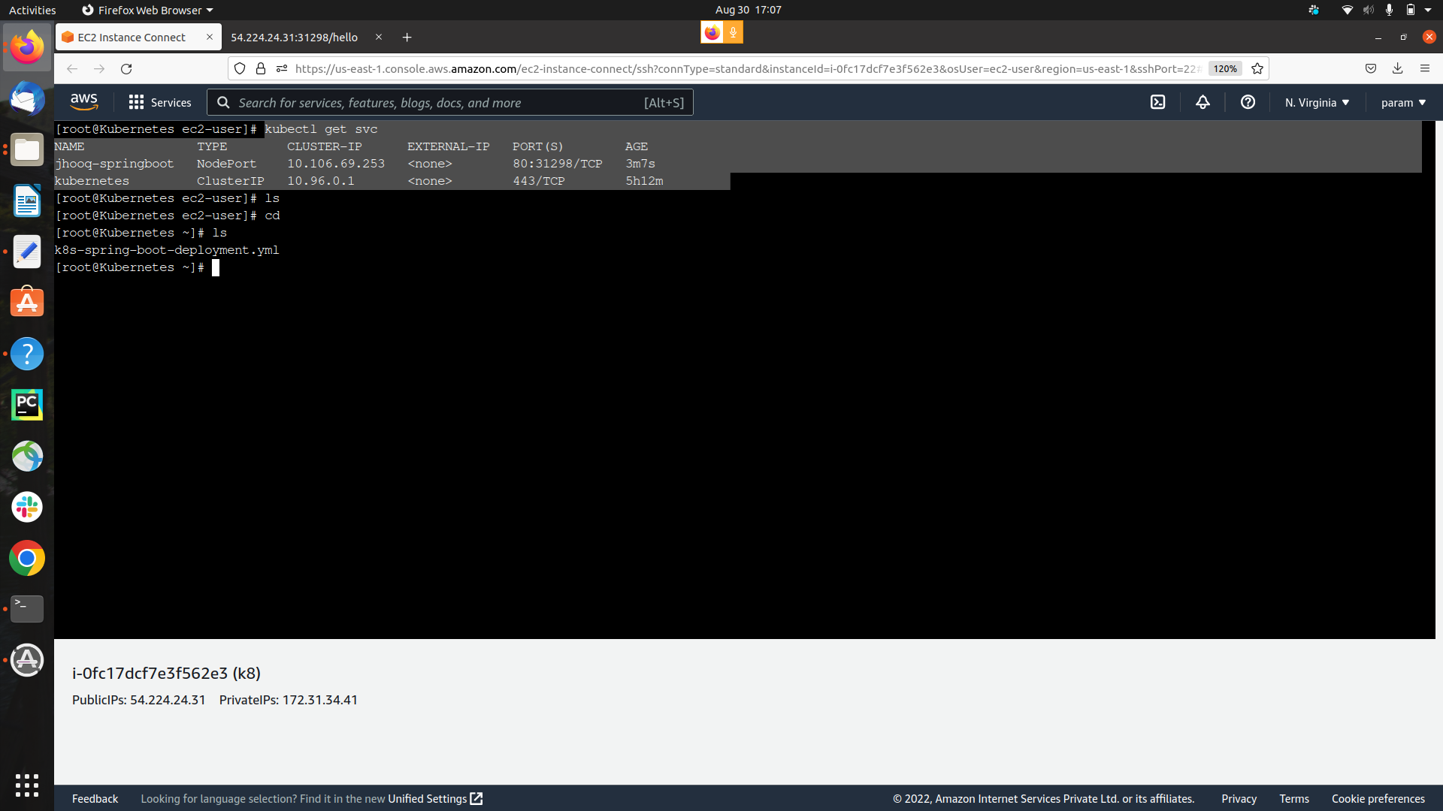

**step 10) Created the pods and container successfully and the NodePort also**

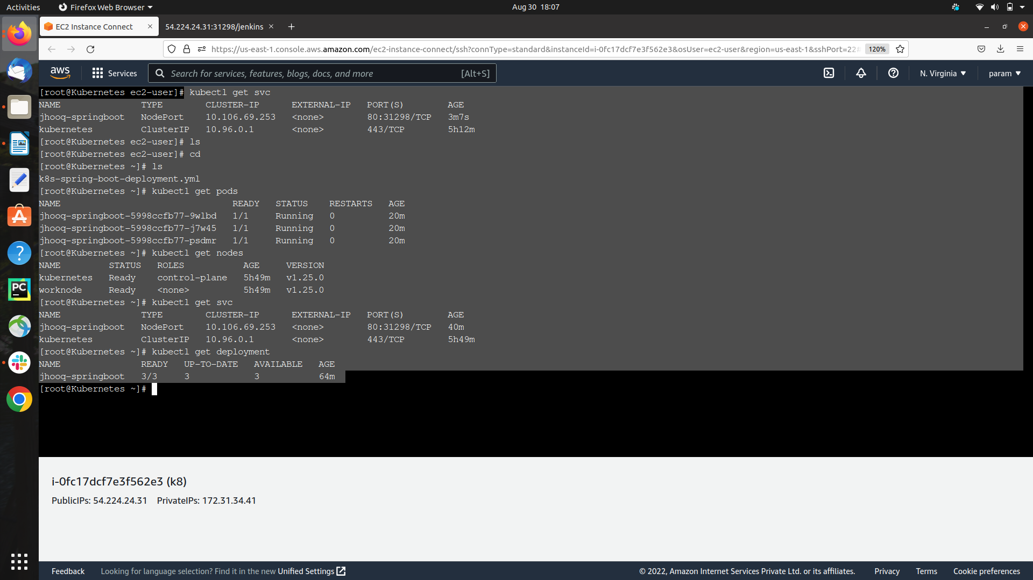

**step 11) Successfully Acceesing the Source Code Using the NodePort Server**

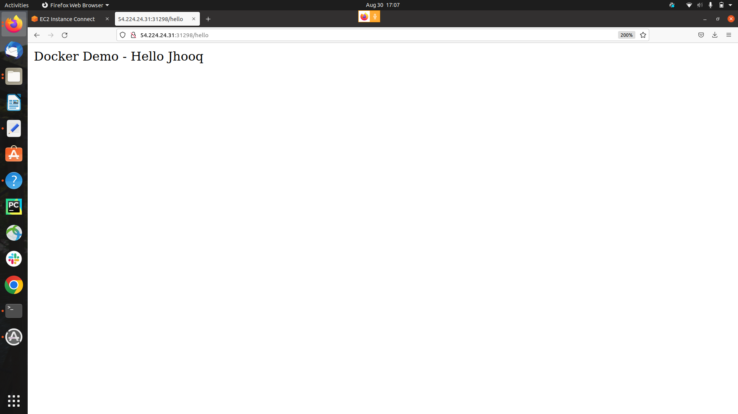**THANK YOU !!**